any information on the previous form has changed, such as demolition dates or if the demolition contractor changes. There is no additional fee for making revisions to Demolition Notification Forms.

State and Federal regulations are very specific about demolition start date revision procedures. If the start date will be later than the original date, give written notice to the Utah DAQ the day before the original start date, or, give verbal notice as soon as possible before the original start date and written notification no later than the original start date. If the date needs to be earlier, make sure the revision is received by the Utah DAQ no less than ten working days prior to the desired start date.

Violation of state and federal asbestos regulations can result in exposure to asbestos, monetary penalties, project delays, and increased waste disposal costs.

During the Demolition

Carefully read and understand the asbestos inspection report before you start the demolition. Contact the Utah certified asbestos inspector that wrote the asbestos inspection report if you have questions about what is in that report.

Watch for suspect asbestos-containing materials that were missed or were not accessible to the Utah certified asbestos inspector and have not been evaluated. Especially watch for materials in voids, walls, under floors, and other inaccessible areas.
Do not convert non-friable roofing and flooring materials to regulated asbestos containing material when processing the material by grinding, sanding, or abrading Category I non-friable asbestos-containing materials.

Notify the Utah DAQ if additional regulated asbestos-containing materials have been disturbed during demolition activities.

Eliminate demolition dust!! Have a dust control plan if the property is over ¼ acre. Insure a proper water supply for the demolition methods being used. Keep debris wet during demolition and loading processes. Use handling techniques that reduce dust (such as releasing debris as low as possible inside the waste container). Make sure non-friable asbestos-containing materials are wet and manifested or accompanied by a waste shipment record.

Questions about Demolition Notification Forms? Please contact the Utah Division of Air Quality at (801) 536-4000.

For Utah certified asbestos inspector and asbestos abatement contractor lists, notification forms, and any other information about Utah asbestos rules, see our web page at:

www.deq.utah.gov/ProgramsServices/
programs/air/asbestos/index.htm

or call the Utah DAQ at (801) 536-4000

Version 1.1 - DAQA-711-15

Demolition

How to Comply with Utah Demolition Requirements

Utah Department of Environmental Quality

Utah Division of
Air Quality

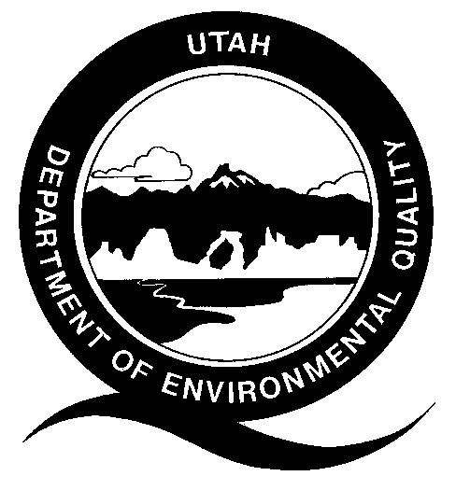

195 North 1950 West
Salt Lake City, Utah 84116

PO Box 144820
Salt Lake City, Utah 84114-4820

Telephone (801) 536-4000
Fax (801) 536-4099

www.deq.utah.gov/ProgramsServices/programs/air/asbestos/index.htm

State and Federal Demolition Laws

Under state and federal asbestos laws, demolition means the wrecking, salvaging, or removing of any load-supporting structural member of a regulated facility together with any related handling operations, or, the intentional burning of any regulated facility. Demolition also means the moving of an entire building that isn’t specifically designed to be moved (moving vehicles or equipment with permanently attached axles such as trailers, motor homes, and mobile homes is NOT considered demolition under Utah law).

If you conduct any of the demolition activities described above, you are subject to the Federal National Emission Standard for Asbestos (Title 40 Code of Federal Regulations Part 61 Subpart M) and/or Utah State Asbestos Rule (Utah Administrative Rule R307-801). Asbestos does not need to be found in the structure for you to be subject to these laws. If you are going to demolish or move a structure, you are required to have an asbestos inspection by a Utah certified asbestos company using a Utah certified asbestos inspector. If friable regulated asbestos-containing material is found, it needs to be removed by a Utah certified asbestos company with Utah certified supervisors and workers prior to demolition.

The Utah Division of Air Quality (DAQ) requires notification and a waiting period of at least 10 business days before you demolish or move a structure. You will also need to notify the Utah DAQ 1 to 10 business days before removing regulated asbestos-containing materials (depending on the amount of asbestos being removed). Also, you may need to get a demolition permit from your local governmental agency. Please contact the city and/or county in which the structure is located to determine if any local demolition permitting requirements exist.

Prior to Demolition

Determine if you are performing a regulated demolition. If you are performing any demolition activities identified above, in a residential structure greater than 100 square feet, you will need to submit a Utah DAQ Demolition Notification Form. Demolition Notification Forms need to be postmarked or delivered to the DAQ at least 10 business days before you start demolition. These forms can be found on the DAQ web site at www.deq.utah.gov/ProgramsServices/programs/air/asbestos/index.htm. If you have any questions, contact the Utah DAQ.

Have an asbestos inspection performed by a Utah certified asbestos inspector. If regulated asbestos-containing material is found, determine if it needs to be removed. Category I non-friable asbestos-containing materials such as resilient floor coverings (sheet vinyl, linoleum, and floor tile) or asphalt roofing products are not required by the Utah DAQ to be removed from a structure unless the building will be used in a live fire training exercise. Other regulated asbestos-containing materials that can become dust, or friable, during live fire training exercises or demolition activities will need to be removed by a Utah certified asbestos company and individuals prior to those activities. Asbestos abatement activities more than 3 square feet or 3 linear feet will also require notification to Utah DAQ and will need to be completed prior to the start of the live fire training exercises or demolition activities.

If the cement from the demolition project will be crushed, recycled, or reused, all regulated asbestos-containing floor mastic (glue) and flooring materials will need to be removed ahead of time.

If asphalt roofing shingles are going to be burned or used as a fuel and are not going to a landfill for disposal, then they will need to be tested for asbestos. If any asbestos is found during testing, then the shingles cannot be burned or used as a fuel and must be disposed at a landfill. Make sure the asbestos inspector knows how the structure will be demolished (live fire training exercise or conventional demolition practices) or if any demolition waste is not going to a landfill so the asbestos inspection can be performed properly.

Demolition Notification Form Requirements

Demolition Notification Forms must be properly completed, submitted, and the appropriate notification fee must be paid to the Utah DAQ at least 10 business days prior to demolition. The dates on the form must be the actual dates when demolition activities are being performed. It is not a window of opportunity or time when demolition may occur. Demolition Notification Forms must be revised when

